**Walchand College Of Engineering, Sangli**

**Department of Computer Science and Engineering**

**Subject: C&NS Lab**

**Batch: B4**

**Name: Gayatri Sopan Gade PRN:2020BTECS00210**

**Assignment 5**

**Title**: Implementation of Transposition Cipher

**Introduction**:

Transposition Cipher is a cryptographic algorithm where the order of alphabets in the plaintext is rearranged to form a cipher text.

Two types of Transposition cipher:

* Rail Fence cipher.
* Columnar Cipher

**1.Rail Fence Cipher:**

The rail fence cipher (also called a zigzag cipher) is a form of transposition cipher. It derives its name from the way in which it is encoded.

Example:

**Encryption**

Input : "attack at once"

Key = 2

Output : atc toctaka ne

**Decryption**

Input : "atc toctaka ne"

Key = 2

Output : attack at once

Code Screenshot:

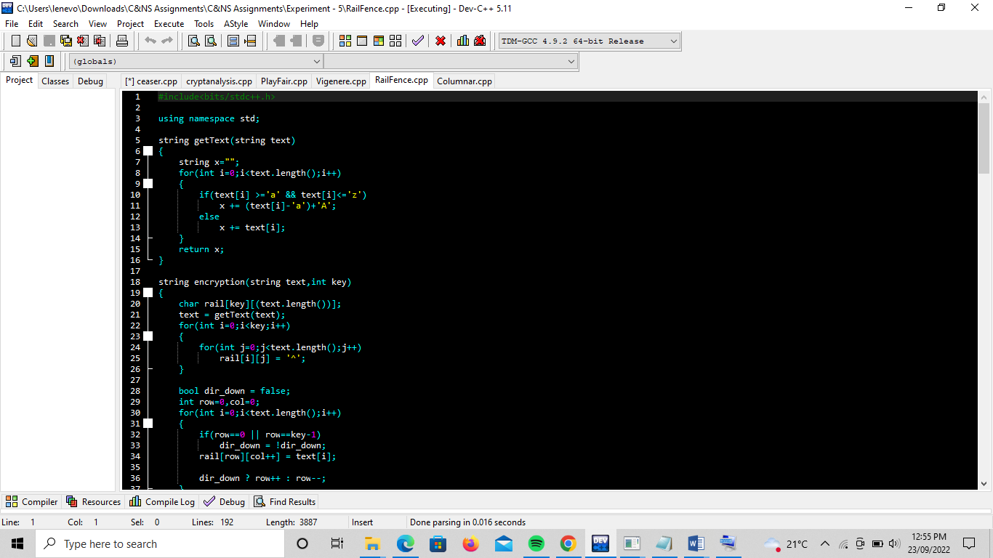

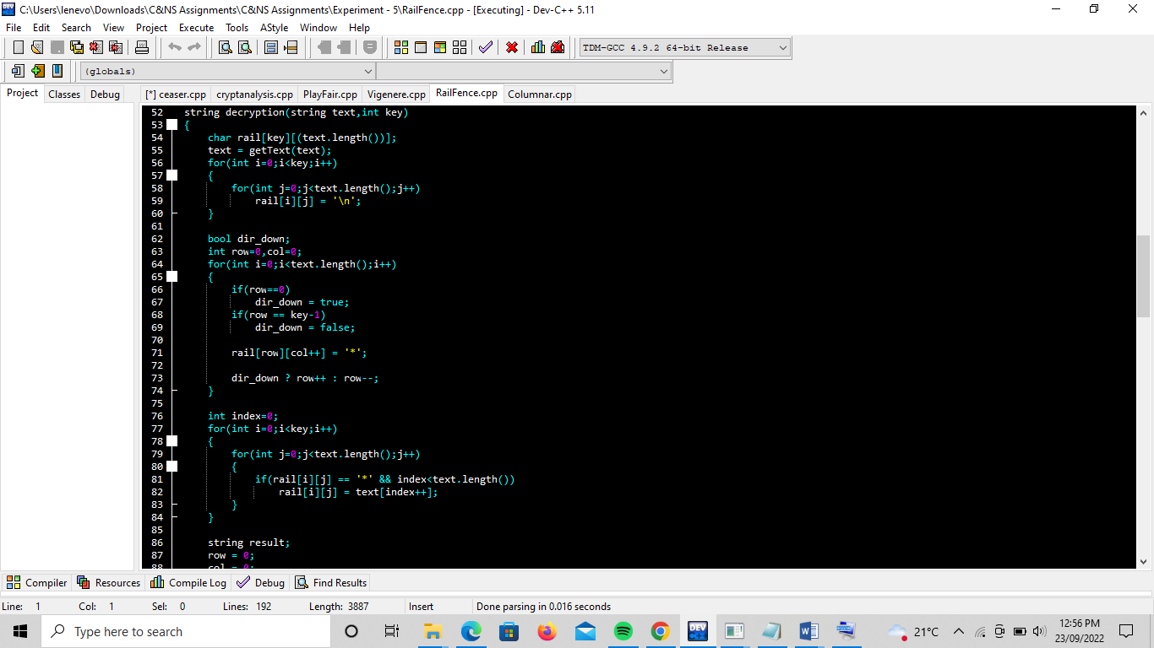

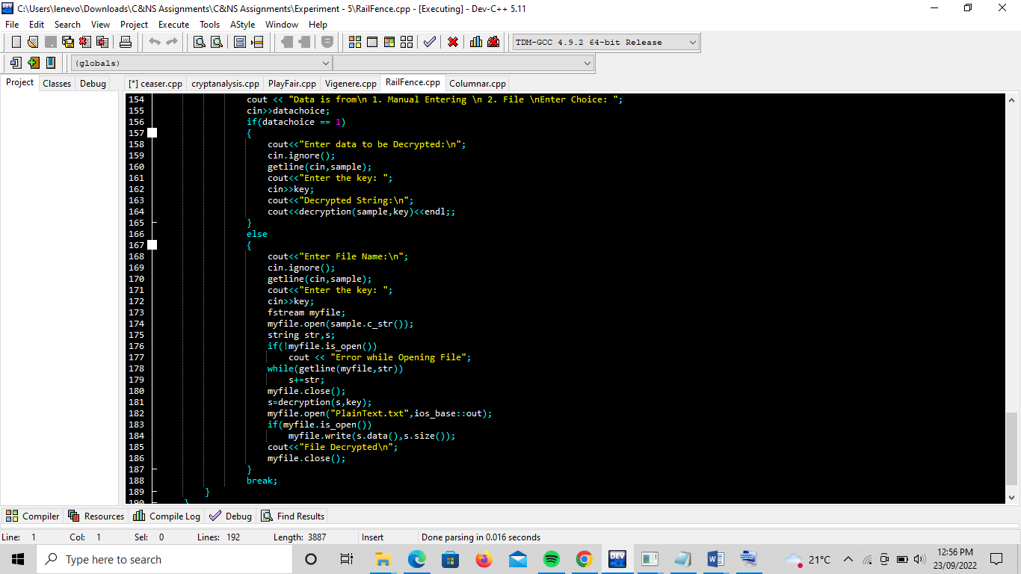

Output:

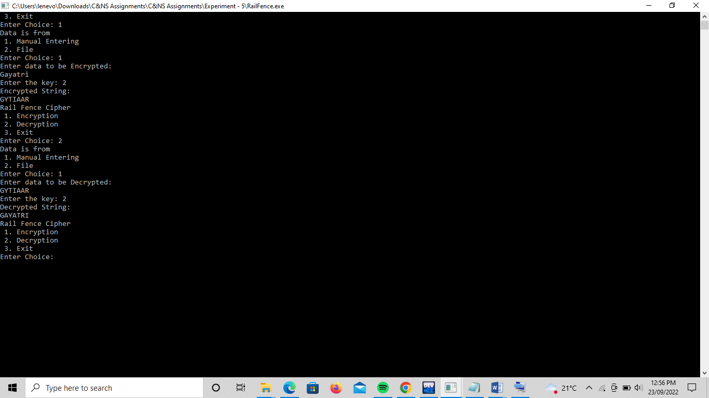

**Columnar Transposition:**

The Columnar Transposition Cipher is a form of transposition cipher just like Rail Fence Cipher. Columnar Transposition involves writing the plaintext out in rows, and then reading the ciphertext off in columns one by one.

**Code Screenshots:**

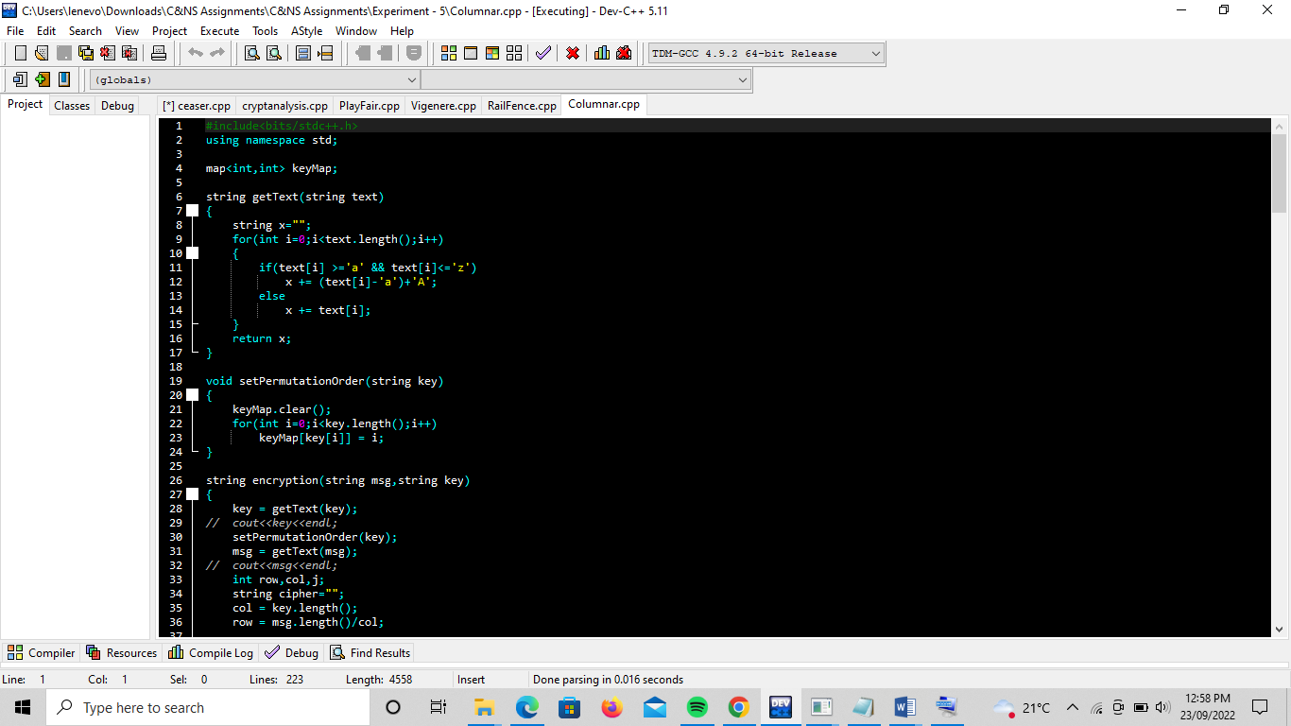

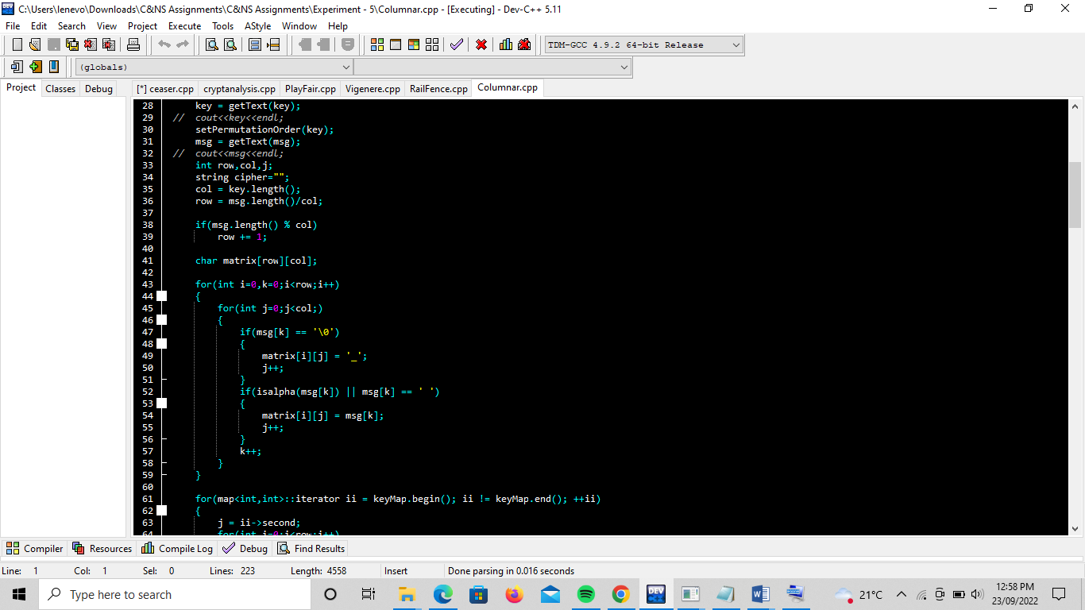

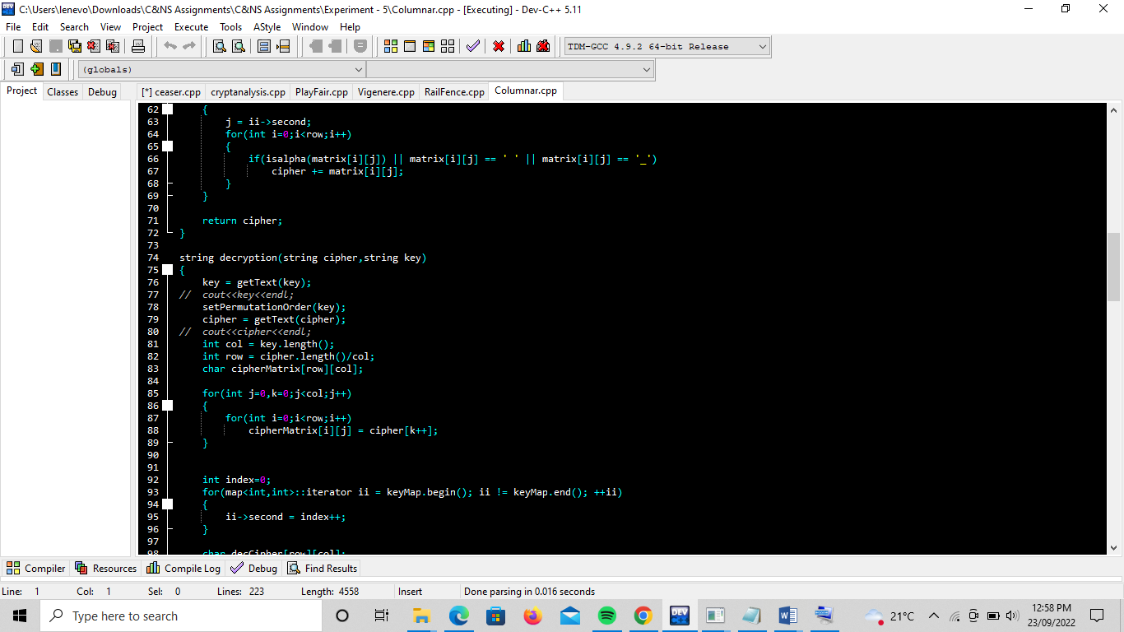

**Output Screenshots:**

